WEEK 2 ASSIGNMENT
Students build:
Mini Student Management App
Features:
- Login page
- Student registration
- Save records locally
- Simple navigation

i.Registration page

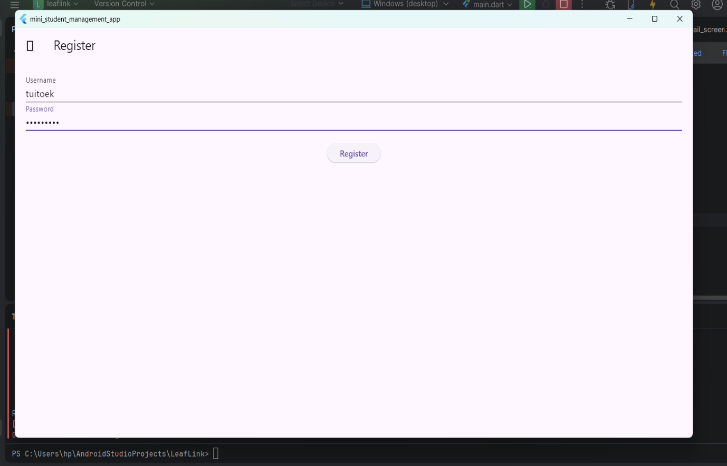
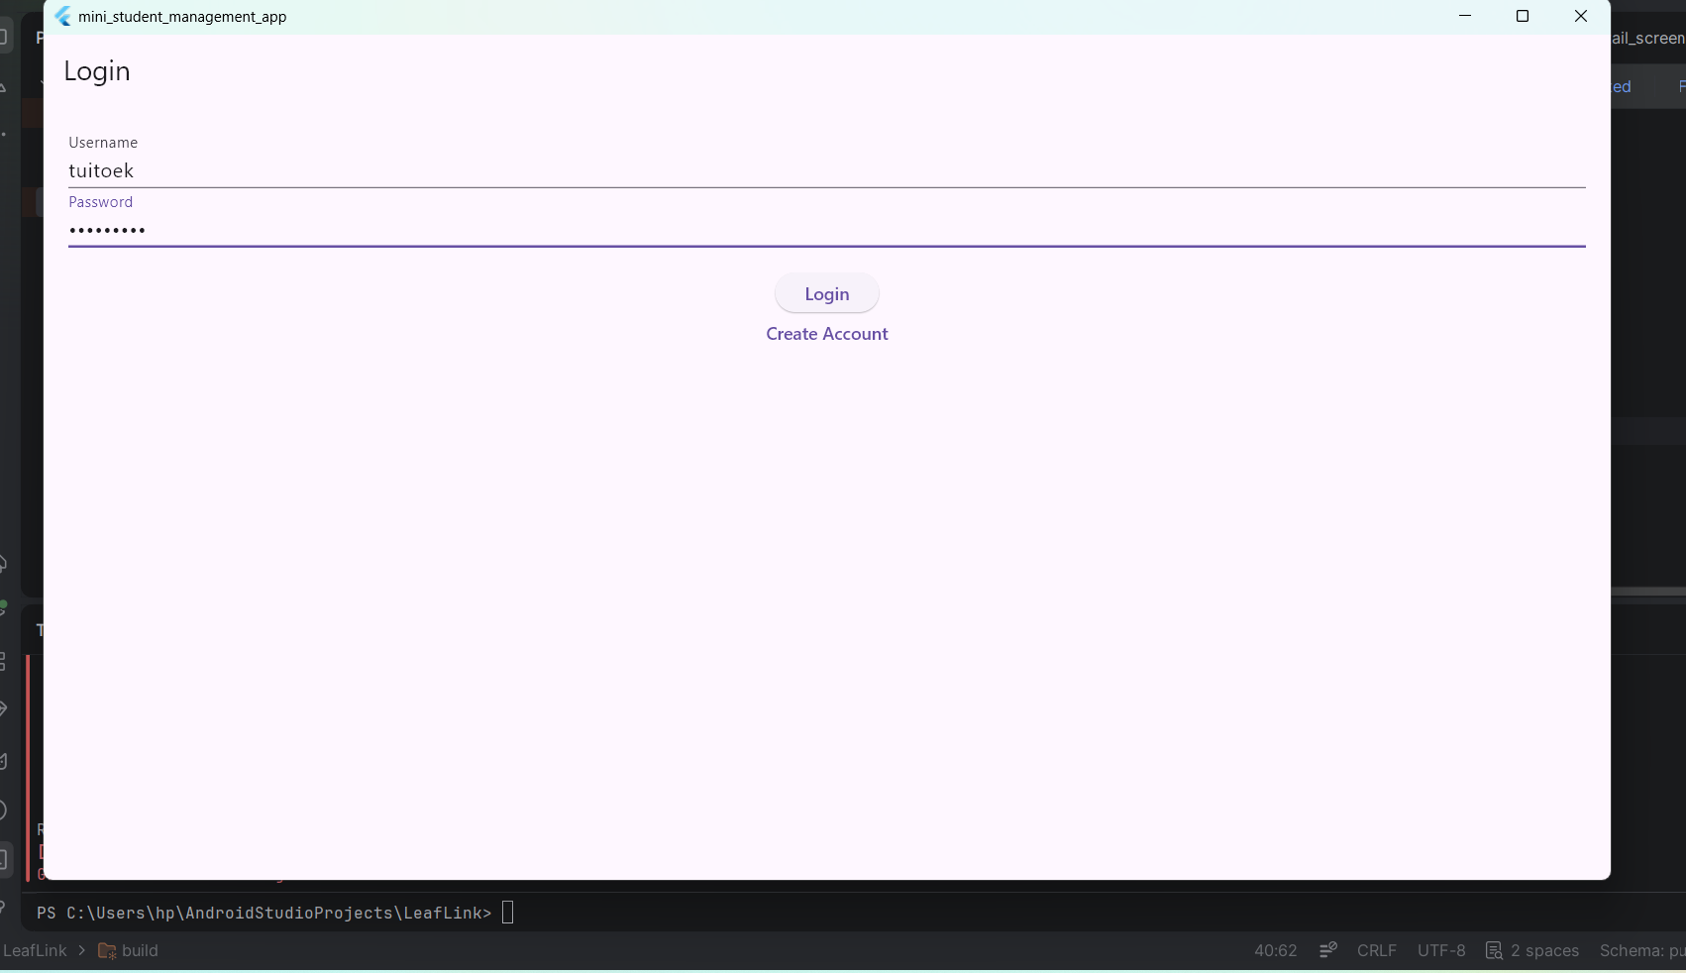
ii.Login page

